HEAD CONNECTION PCB

- PARTS:

QUANTITY: PART #: NOMENCLATURE: LENGTH:

1 PER MACHINE 13520- CAP, CER, .1μF, 50V N/A

2 PER MACHINE 14046- CAP, ELECT., 220μF, 16V N/A

4 PER MACHINE 13521- CAP, CER, .01μF, 50V N/A

2 PER MACHINE 17669- HEADER, 34-PIN, STR, LOW PRO N/A

2 PER MACHINE 15348- RESISTOR, 1KΩ, ¼W, 5% N/A

6 PER MACHINE 15356- RESISTOR, 2.2KΩ, ¼W, 5% N/A

4 PER MACHINE 10464- IC, -26LS31 N/A

2 PER MACHINE 10395- IC, -ULN2003 N/A

6 PER MACHINE 17681- HEADER, 3-PIN, MOLEX N/A

13 PER MACHINE 17682- HEADER, 2-PIN, MOLEX N/A

5 PER MACHINE 17683- HEADER, 4-PIN, MOLEX N/A

1 PER MACHINE 217009-2 PCB, BLANK, HEAD CONNECTION N/A

- ASSEMBLY:

- INSERT AND SOLDER THE RESISTORS, ACCORDING TO DIAGRAM 1.

- INSERT AND SOLDER THE SMALLCAPACITORS, ACCORDING TO DIAGRAM 1.

- INSERT AND SOLDER THE ICS, ACCORDING TO DIAGRAM 1.

- INSERT AND SOLDER THE 34-PIN HEADERS, ACCORDING TO DIAGRAM 1.

- INSERT AND SOLDER THE OTHER HEADERS, ACCORDING TO DIAGRAM 1.

- INSERT AND SOLDER THE TWO ELECTROLYTIC CAPACITORS, ACCORDING TO DIAGRAM 1.

NOTE 1
IT IS CRITICAL TO PLACE THE ICS, ELECTROLYTIC CAPACITORS, AND HEADERS CORRECTLY, ACORDING TO DIAGRAM 1. ANY VARIATION MAY CAUSE MALFUNCTION AND DAMAGE TO CIRCUITRY.
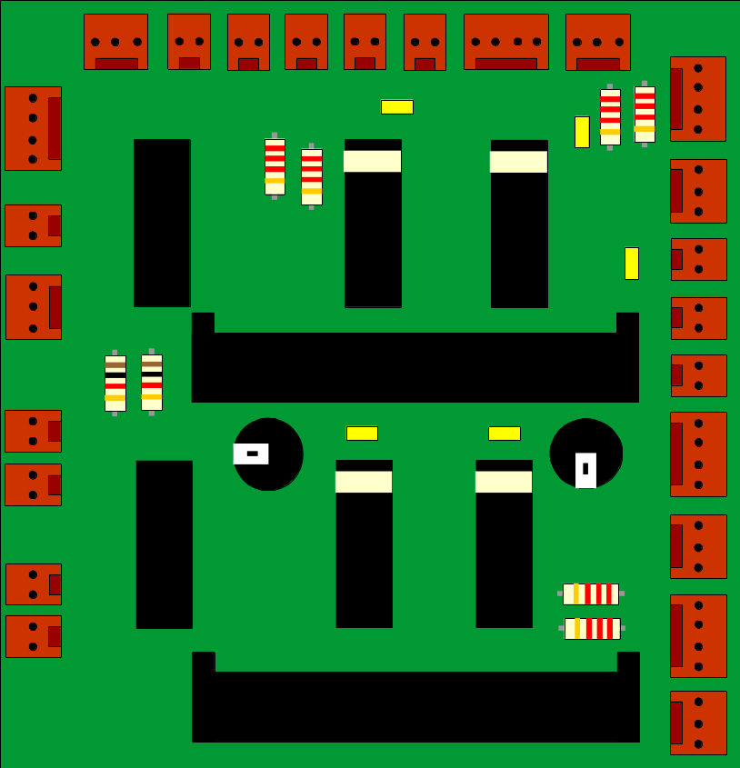

DIAGRAM 1

